Storing the information you need — Variables

What is a variable?
- A variable is a container for a value,
- like a number we might use in a sum, or
- a string that we might use as part of a sentence.
But one special thing about variables is that their contained values can change.
Another special thing about variables is that they can contain just about anything — not just strings and numbers. Variables can also contain complex data and even entire functions to do amazing things.
Note: We say variables contain values. This is an important distinction to make. Variables aren't the values themselves; they are containers for values. You can think of them being like little cardboard boxes that you can store things in.
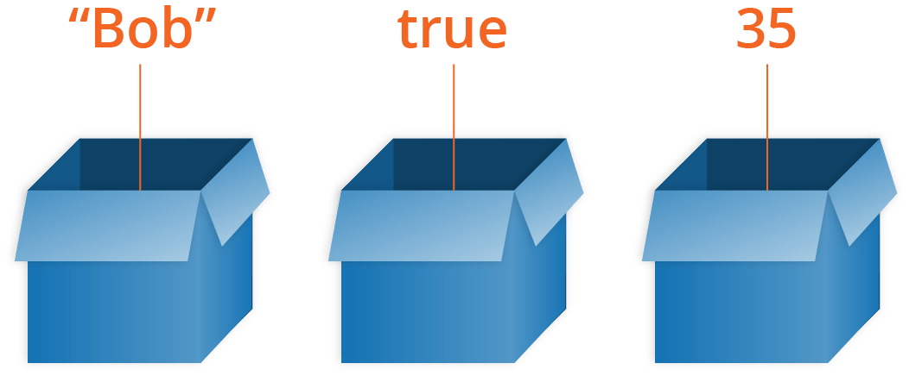

Declaring a variable
To use a variable, you've first got to create it — more accurately, we call this declaring the variable.
let myName;
let myAge;
They currently have no value; they are empty containers. When you enter the variable names, you should get a value of undefined returned. If they don't exist, you'll get an error message — try typing in
scoobyDoo;
Note: Don't confuse a variable that exists but has no defined value with a variable that doesn't exist at all — they are very different things. In the box analogy you saw above, not existing would mean there's no box (variable) for a value to go in. No value defined would mean that there IS a box, but it has no value inside it.

The difference between var and let
At this point you may be thinking "why do we need two keywords for defining variables?? Why have var and let?".
The reasons are somewhat historical. Back when JavaScript was first created, there was only var. This works basically fine in most cases, but it has some issues in the way it works — its design can sometimes be confusing or downright annoying. So, let was created in modern versions of JavaScript, a new keyword for creating variables that works somewhat differently to var, fixing its issues in the process.
let reference page).
For a start, if you write a multiline JavaScript program that declares and initializes a variable, you can actually declare a variable with var after you initialize it and it will still work. For example:
myName = 'Chris';

function logName() {
console.log(myName);
}

logName();

var myName;
Note: This won't work when typing individual lines into a JavaScript console, just when running multiple lines of JavaScript in a web document.
This works because of hoisting — read var hoisting for more detail on the subject.
Hoisting no longer works with let. If we changed var to let in the above example, it would fail with an error. This is a good thing — declaring a variable after you initialize it results in confusing, harder to understand code.
Secondly, when you use var, you can declare the same variable as many times as you like, but with let you can't. The following would work:
var myName = 'Chris';
var myName = 'Bob';
But the following would throw an error on the second line:
let myName = 'Chris';
let myName = 'Bob';
You'd have to do this instead:
let myName = 'Chris';
myName = 'Bob';
Again, this is a sensible language decision. There is no reason to redeclare variables — it just makes things more confusing.
For these reasons and more, we recommend that you use let as much as possible in your code, rather than var. There is no reason to use var, unless you need to support old versions of Internet Explorer with your code (it doesn't support let until version 11; the modern Microsoft Edge browser supports let just fine).

Updating a variable
Once a variable has been initialized with a value, you can change (or update) that value by giving it a different value. Try entering the following lines into your console:
myName = 'Bob';
myAge = 40;

Variable types

Numbers
You can store numbers in variables,
- either whole numbers like 30 (also called integers) or
- decimal numbers like 2.456 (also called floats or floating point numbers).

Strings
Strings are pieces of text. When you give a variable a string value, you need to wrap it in single or double quote marks; otherwise, JavaScript tries to interpret it as another variable name.
let dolphinGoodbye = 'So long and thanks for all the fish';

Arrays
An array is a single object that contains multiple values enclosed in square brackets and separated by commas. Try entering the following lines into your console:
let myNameArray = ['Chris', 'Bob', 'Jim'];
let myNumberArray = [10, 15, 40];

Objects
In programming, an object is a structure of code that models a real-life object. You can have a simple object that represents a box and contains information about its width, length, and height, or you could have an object that represents a person, and contains data about their name, height, weight, what language they speak, how to say hello to them, and more.

Dynamic typing
JavaScript is a "dynamically typed language", which means that, unlike some other languages, you don't need to specify what data type a variable will contain (numbers, strings, arrays, etc).
For example, if you declare a variable and give it a value enclosed in quotes, the browser treats the variable as a string:
let myString = 'Hello';
Even if the value contains numbers, it is still a string, so be careful:
let myNumber = '500'; // oops, this is still a string
typeof myNumber;
myNumber = 500; // much better — now this is a number
typeof myNumber;

Constants in JavaScript
Many programming languages have the concept of a constant — a value that once declared can't be changed.
In the early days of JavaScript, constants didn't exist. In modern JavaScript, we have the keyword const, which lets us store values that can never be changed:
const daysInWeek = 7;
const hoursInDay = 24;
const works in exactly the same way as let, except that you can't give a const a new value. In the following example, the second line would throw an error:
const daysInWeek = 7;
daysInWeek = 8;

